Washington
Interoperable Communications

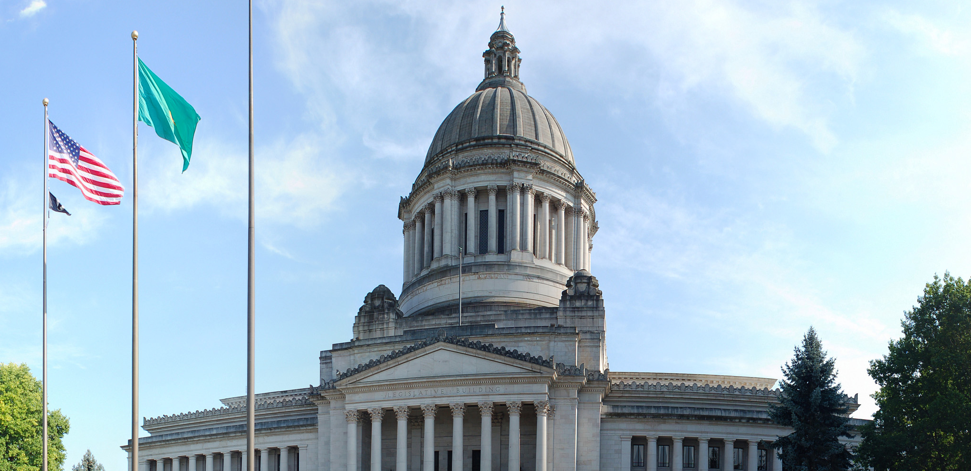
Statewide Interoperability Coordinator Reference Guide

DRAFT
WARNING: This document is FOR OFFICIAL USE ONLY (FOUO). It contains information that may be exempt from public release under the Freedom of Information Act (5 U.S.C. 552). It is to be controlled, stored, handled, transmitted, distributed, and disposed of in accordance with DHS policy relating to FOUO information and is not to be released to the public or other personnel who do not have a valid "need-to-know" without prior approval of an authorized DHS official.
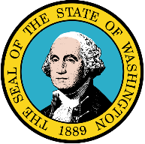
Washington Interoperable Communications Statewide Interoperability Coordinator (SWIC)
Reference Guide

Version # | Editor | Date Modified | Section Modified | Modification Description

Table of Contents
Reference Guide Overview
State Overview
Interoperable Communications Governance
State Agencies with Roles in Emergency Communications
Points of Contact
Agencies with Government Emergency Telecommunications Card (GETS) and Wireless Priority Services (WPS) Card Holders
Washington Homeland Security Regions
Washington Key Agencies / Facilities / Infrastructure
Washington Disaster Declarations by County
SWICs in Adjacent States
Washington Tribal Information
Grant Information
Washington National Emergency Communications Plan (NECP) Goal 2 Results
Washington Statewide Communication Interoperability Plan
Washington Radio Systems and Infrastructure
Washington Tower Locations
Washington Radio Systems
Washington Tactical and Incident Resources
Communications Equipment
Personnel Resources
Technical Assistance
Washington 9-1-1 and Next Generation 9-1-1
Washington 9-1-1 Program
Washington Public Safety Answering Points Locations
Washington PSAPs and Points of Contact
Next Generation 9-1-1
Broadband/FirstNet
References

Reference Guide Overview

State Overview
This section presents an overview of the State’s governance structure and capabilities. The section includes information on the State’s key administrators and agencies, grant information, and county level communications interoperability capabilities from the National Emergency Communications Plan (NECP) Goal 2 Survey.

Statewide Communication Interoperability Plan
The Statewide Communication Interoperability Plan (SCIP) is a locally-driven, multi-disciplinary plan to enhance emergency communications statewide. The SCIP outlines the current and future vision for communication interoperability within the State and should align emergency response agencies to meet that vision. The most recent SCIP will be featured here along with the most recent SCIP Implementation Report.

Radio Systems and Infrastructure
This section provides a geographic overview of the State’s systems and key infrastructure, including State radio systems and tower locations.

Tactical and Incident Resources
Tactical and incident resources are essential to both Communications Unit Leaders (COMLs) and first responders as it provides the scope of interoperable assets available in a given area as well as how the assets are shared and prioritized. These resources also help in supporting interoperable and emergency communications across a geographic area. This section will encompass information on a myriad of tactical and incident resources, including the Communication Unit and caches around the State.

Technical Assistance
As part of their mission the Department of Homeland Security’s Office of Emergency Communication (DHS/OEC) offers a wide range of technical assistance programs to enhance the capability of emergency responders and government officials to communicate in any emergency situation. This section summarizes previous and upcoming technical assistance within the State.

9-1-1 and NG9-1-1
Within this section the State’s 9-1-1 program, including governance structure and Public Safety Answering Points (PSAPs), is presented. Additionally, State progress on Next Generation 9-1-1 planning or implementation is overviewed.

Broadband/FirstNet
FirstNet oversees the planning and construction of the National Public Safety Broadband Network, a secure, reliable, and dedicated nationwide interoperable digital network for emergency responders. This section provides state results of FirstNet requirements along with important broadband related information.

References
This section encompasses federal contact information, important websites, and a record of CASM users throughout the state.

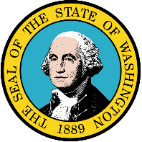
State Overview

Interoperable Emergency Communications Governance

Washington’s Governing Body:The Washington State governing body is the State Interoperability Executive Committee (SIEC).

Structure: The SIEC manages how State public safety agencies use wireless communications to carry out their daily operations and coordinate responses during major events. Local governments determine how this is done at the local level. The SIEC relies heavily on input from local stakeholders and identifies strategies to more closely collaborate with local agencies on interoperability efforts. The SIEC serves as a part of the State’s multi-jurisdictional Domestic Security Infrastructure. This organization facilitates decision making and information sharing across the State’s public safety disciplines at all levels of government.

SIEC membership is divided roughly in half between local and state representatives. The 2003 Legislation limits the number of voting members to fifteen. The followingorganizations arerepresented in theSIEC:Washington Traffic Safety Commission, Association of Washington Cities; Regional EmergencyServicesAssociation; WA Association of FireChiefs;WA Association ofSheriffs and PoliceChiefs; WA Department of Corrections; WA Department ofInformation Services;WA Department of Natural Resources; WA Department of Transportation; WA Officeof theStateFireMarshall; WA MilitaryDepartment; WA State Patrol; WA State EmergencyManagement Division; Washington State Emergency Managers Association;WA State Association of Counties; Association of Washington Cities; Northwest Tribal Emergency Management Council and Washington Tribes.

OtherInformation

TheSIEC servesas a part of thestateof Washington’s multi-jurisdictionalDomesticSecurity infrastructure, “Team Washington.” The purpose of this organization is to reducevulnerabilities and defend againstthe disasters created bydomestic attacks and natural or technological hazards.

In addition to the SIEC, Washington also has the Washington State Homeland Security regional planning and coordination structure, which is divided into nine regions consisting of one or more geographical boundaries. This regional configuration was implemented to distribute Federal grant funds, develop emergency responder equipment priority lists, plan and execute training and exercise programs, create regionally-based mutual aid plans, and develop volunteer infrastructure to support citizens’ involvement in
HomelandSecurity initiatives.

Each region has an interdisciplinary council that determines priorities for the area. The council assesses vulnerabilities and determines how to address enhancements to the region's capabilities. One county within each region acts as the regional lead. The regional lead implements the vision of the regional council and is ultimately responsible for the projects, fiscal accountability, and contract management for the region. Each regional lead has a regional coordinator who is specifically tasked to work with the regional partners at the city, tribal, and special purpose district levels to keep them engaged in the process.

Authorization/Legislation
TheSIEC wasestablishedbylegislation(Revised Code ofWashington 43.105.330)onJuly1, 2003asa permanentsubcommitteeofthe state ISB.

The SIEC was re-established in 2011 in Engrossed Substitute Senate Bill 5931. SIEC responsibilities and committee membership, representation, and composition remain unchanged. The one difference between the original legislation and the new law is that SIEC members are appointed by the new State Chief Information Officer (CIO).

Due to legislative action, there was no need for a formal MOA or MOU to create the SIEC. However, Federal, State, local, tribal, and NGOs have at times entered into agreements to foster interoperability and sharing of resources.
Link
http://apps.leg.wa.gov/RCW/default.aspx?cite=43.105.330

2011 legislation: http://apps.leg.wa.gov/documents/billdocs/2011-12/Pdf/Bills/Senate%20Bills/5931-S.E.pdf
Statewide InteroperabilityCoordinator (SWIC)
Robert Schwent, Washington State Patrol
(360)534-0601
Robert.Schwent@wsp.wa.gov

Note: The Legislation doesnot list theState Interoperability Coordinator asa formalizedposition withintheSIEC.

State Agencies with Roles in Emergency Communications

Washington State Military Department

Emergency Management Division: The Division has overall responsibility for planning and coordinating the emergency telecommunications program within the state. The Telecommunications Section manages, maintains, and repairs telecommunications, information technology, and warning systems statewide, and is responsible for these resources within the State Emergency Operations Center (SEOC). The Section also coordinates with the State’s amateur radio organizations (RACES and ARES) who provide backup communications systems as needed.

Washington State Department of Enterprise Services

The Department of Enterprise Services is responsible for planning and coordinating the information technology program within the state. The Department maintains the state government telecommunications and information technology infrastructure, and provides staff to the SEOC as necessary. The Department works closely with the Emergency Management Division to coordinate emergency communications response.

Washington State Utilities and Transportation Commission

The State Utilities and Transportation Commission is responsible for monitoring and reporting to the SEOC the recovery and restoration of regulated telecommunications services. The Commission may also provide staff to the SEOC.

Other Agencies with Emergency Communications Capabilities

Other State agencies that may provide emergency communications personnel, equipment, or other resources include:
- Department of Corrections | - Washington State Patrol
- Military Department – National Guard | - Department of Natural Resources
- Department of Transportation | - Department of Fish and Wildlife
- Parks and Recreation Commission

10th Civil Support Team:The 10th Civil Support Team (CST) is the Washington National Guard's quick response element for Chemical, Biological, Radiological, Nuclear and high-yield Explosive (CBRNE) incidents. They are full-time National Guard Soldiers and Airmen who stand ready to support civil authorities in times of crisis. Their mission is to support civil authorities at domestic CBRNE or natural disaster incident sites by assessing current and projected consequences, identifying CBRNE agents/substances, advising on response measures and assisting with appropriate requests for state and federal support. The 10th CST is composed 22 full-time Army and Air National Guard. http://washingtonguard.org/10thCST/
Location: Tacoma, Washington
Commanding Officer: Lt. Col. Scott Humphrey

Points of Contact

Key State Agency Officials:
Agency Position | Name | Phone
Adjutant General, Washington Military Department | Maj. Gen. Bret D. Daugherty | 253-512-8201
Director, Division of Emergency  Management | Robert Ezelle | 253-512-7001
Homeland Security / E911 Unit Manager, Division of Emergency Management | Ziggy Dahl | 253-512-7468
Chief, Washington State Patrol | John R. Batiste | 360-596-4101
State Fire Marshall | Charles Duffy | 360-596-3902
Secretary, Department of Health | John Wiesman | 360-236-4030
Chief Of Emergency Preparedness and Response, Department of Health | Michael Loehr | 360-236-4068
Secretary, Department of Corrections | Bernard Warner | 360-725-8810
Director, Department of Enterprise Services | Chris Liu | 360-407-9202
State Chief Information Officer | Michael Cockrill | 360-902-7325
Secretary, Department of Transportation | Lynn Peterson | 360-705-7000
Emergency Preparedness Grants Supervisor, Division of Emergency Management | Charma Anderson | 253-512-7064
Chairman, Washington State Utilities and Transportation Commission | David W. Danner | 360-664-1208

Key State Emergency Communications Officials:
Agency Position | Name | Phone
SIEC Chairperson, Office of the Chief Information Officer | Bill Schrier | 360-902-3574
Logistics Program Manager, Division of Emergency Management | Craig Ginn | 253-512-7097
Assistant Chief, Technical Services Bureau, State Patrol | Shawn Berry | 360-596-4106
Communications, Department of Corrections | Steve Gehrke | 360-725-8213
E911 Unit Manager, Division of Emergency Management | Ziggy Dahl | 253-512-7468
Director of Communications, Department of Health | Tim Church | 360-236-4077

Agencies with Government Emergency Telecommunications Card (GETS) and Wireless Priority Services (WPS) Card Holders

Organization | GETS | WPS
WA - AIRLIFT NORTHWEST | 1 | 0
WA - CONSOL TECH SVCS | 36 | 0
WA - DEPT OF COMMERCE | 10 | 1
WA - DEPT OF CORRECTIONS | 33 | 10
WA - DEPT OF ECOLOGY | 44 | 11
WA - DEPT OF FISH & WILDLIFE | 31 | 18
WA - DEPT OF LICENSING | 54 | 0
WA - DEPT OF NATURAL RESOUCES | 44 | 1
WA - DEPT OF REVENUE | 1 | 1
WA - DEPT OF SOCIAL & HLTH SVCS | 57 | 1
WA - DES | 45 | 10
WA - DIV OF DDS | 8 | 0
WA - DOA | 51 | 3
WA - DOH | 42 | 35
WA - DOT | 658 | 0
WA - DSHS - ADSA - DDD - REG 6 | 121 | 16
WA - DSHS - APS - REG 3 | 15 | 0
WA - DSHS - COMM SVCS DIV | 94 | 1
WA - DSHS - HOME & COMM SVCS | 23 | 7
WA - DSHS - HOME & COMM SVCS REG 1 | 14 | 0
WA - DSHS - HOME & COMM SVCS REG 4 | 3 | 2
WA - DSHS - JUV JUSTICE & REHAB ADMIN | 3 | 0
WA - DSHS - WESTERN STATE HOSP | 15 | 0
WA - DSHS CHILD SUPPORT REG 6 | 18 | 0
WA - DSHS CHILDREN ADMIN REG 6 | 9 | 3
WA - DSHS CHILDRENS ADMIN REG 1 | 108 | 0
WA - DSHS DVR REG 4 | 21 | 0
WA - DSHS FSA FSD RBC 2 | 3 | 0
WA - DSHS RESIDENTIAL CARE SVCS REG 4 | 7 | 5
WA - ECON SVCS ADMIN OFC | 6 | 0
WA - ECONOMIC SVCS ADMIN OPS | 20 | 0
WA - EM DIV - EA | 1 | 0
WA - EVERGREEN STATE COLLEGE | 28 | 11

(GETS and WPS Continued)
Organization | GETS | WPS
WA - HIGHLINE COMM COL | 4 | 4
WA - LEOFF PLAN 2 BD | 4 | 0
WA - LIQUOR CONTROL BOARD | 26 | 0
WA - MILITARY DEPT | 78 | 1
WA - OFC FINANCIAL MGMT | 5 | 0
WA - OFC OF LIEUTENTANT GOVERNOR | 2 | 0
WA - OFC OF THE ATTY GEN | 59 | 1
WA - PENINSULA COL | 2 | 0
WA - SECRETARY OF STATE | 3 | 0
WA - STATE DEPT OF LABOR INDUSTRIES | 51 | 0
WA - STATE DEPT OF RETIREMENT SYS | 12 | 0
WA - STATE DEPT OF VETERANS AFFAIRS | 45 | 0
WA - STATE PARKS | 19 | 11
WA - STATE PATROL | 76 | 42
WA - UTLS & TRANS COMMISSION | 23 | 0
TOTAL | 2,035 | 197

Washington Homeland Security Regions
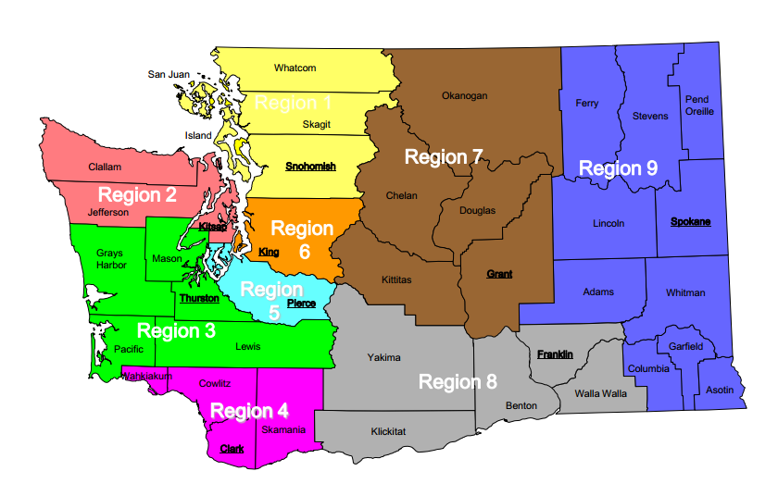

Washington Key Agencies/Facilities/Infrastructure
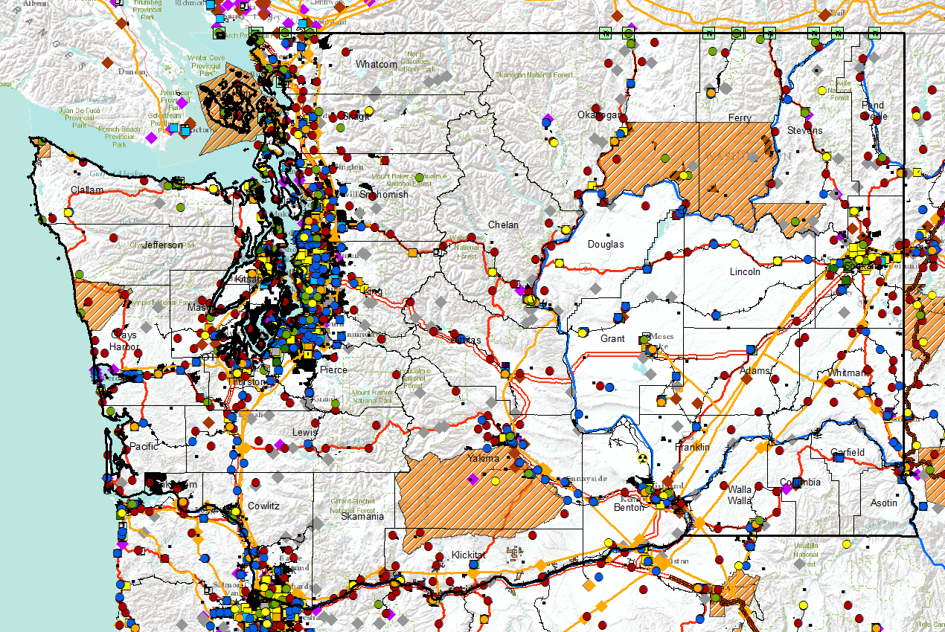
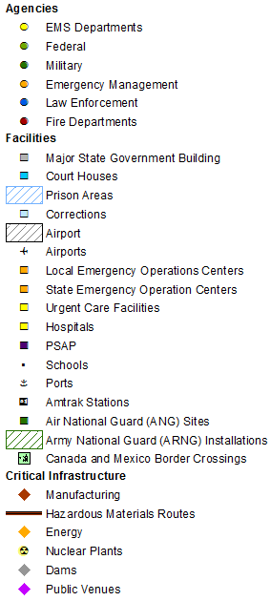
(Stadiums, race tracks, state fairgrounds, etc.)

Washington Disaster Declarations by County
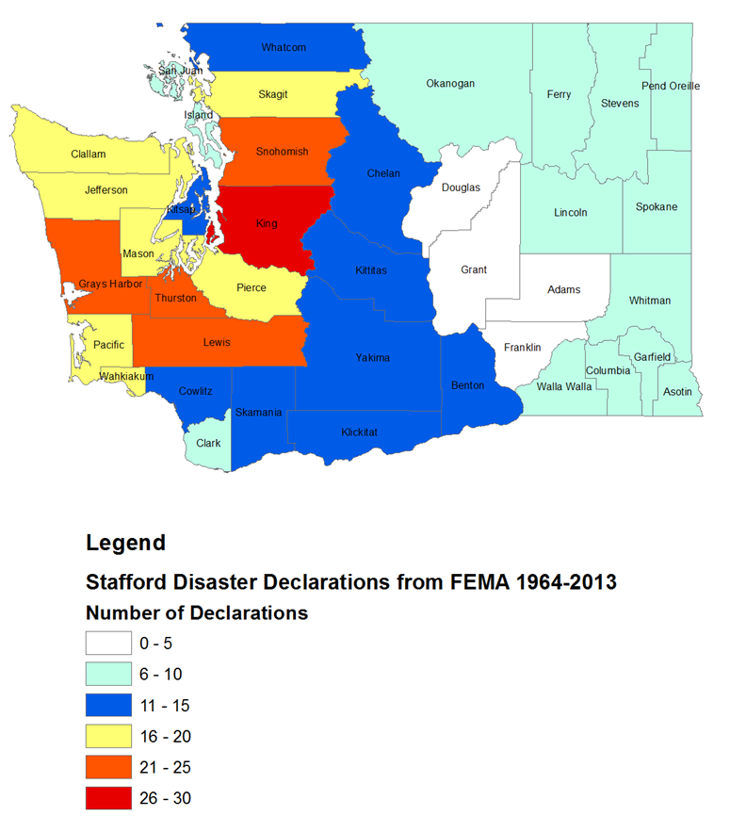

Washington Disaster Declarations 2011- 2014
Disaster | Incident Period
Washington Wildfires (DR-4188) | July 9 – August 14, 014
Washington Hansel Fire (FM-5072) | August 2, 2014
Washington Snag Canyon Fire (FM-5071) | August 2, 2014
Washington Wildfires (EM-3371) | July 9, 2014
Washington Saddle Mountain Fire (FM-5064) | July 19, 2014 - July 20, 2014
Washington Watermelon Hill Fire (FM-5063) | July 19, 2014 - July 22, 2014
Washington Carlton Complex Fire (FM-5062) | July 16, 2014
Washington Chiwaukum Fire (FM-5061) | July 15, 2014
Washington Mills Canyon Fire (FM-5059) | July 8, 2014
Washington Lake Spokane Fire (FM-5058) | July 9, 2014 - July 14, 2014
Washington Flooding and Mudslides (DR-4168) | March 22, 2014 - April 29, 2014
Washington Flooding and Mudslides (EM-3370) | March 22, 2014 - April 29, 2014
Washington Eagle Fire (FM-5048) | August 20, 2013 - August 28, 2013
Washington Mile Post 10 Fire (FM-5042) | August 10, 2013 - August 14, 2013
Washington Colockum Tarps Fire (FM-5038) | July 27, 2013 - August 14, 2013
Washington Severe Storm, Straight-line Winds, and Flooding (DR-4083) | July 20, 2012 - July 21, 2012
Washington Table Mountain Fire (FM-5020) | September 19, 2012
Washington Peavine Fire (FM-5018) | September 12, 2012
Washington Poison Fire (FM-5017) | September 12, 2012 - October 31, 2012
Washington Byrd Canyon Fire (FM-5015) | September 10, 2012 - September 19, 2012
Washington Barker Canyon Fire (FM-5013) | September 9, 2012 - September 16, 2012
Washington 1st Canyon Fire (FM-5012) | September 9, 2012 - September 19, 2012
Washington Highway 141 Fire Complex (FM-5011) | September 5, 2012 - September 11, 2012
Washington Taylor Bridge Fire (FM-5005) | August 3, 2012
Washington Monastery Fire Complex (FM-2966) | September 8, 2011 - December 31, 1969
Washington Severe Winter Storm, Flooding, Landslides, and Mudslides (DR-1963) | January 11, 2011 - January 21, 2011

SWICs in Adjacent States
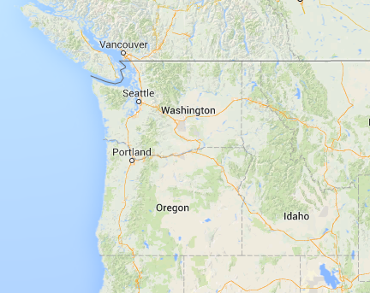

State | Name | Agency | Phone | Email
Alaska | Matthew Leveque | Alaska Homeland Security and Emergency Management | (907) 269-5697 | matt.leveque@alaska.gov
Idaho | Robert Hugi | Idaho Bureau of Homeland Security | (208) 288-4007 | rhugi@bhs.idaho.gov
Oregon | Steve Noel | Oregon Wireless Interoperability Network | (503) 934-6940 | Steve.Noel@odot.state.or.us

Washington Tribal Information

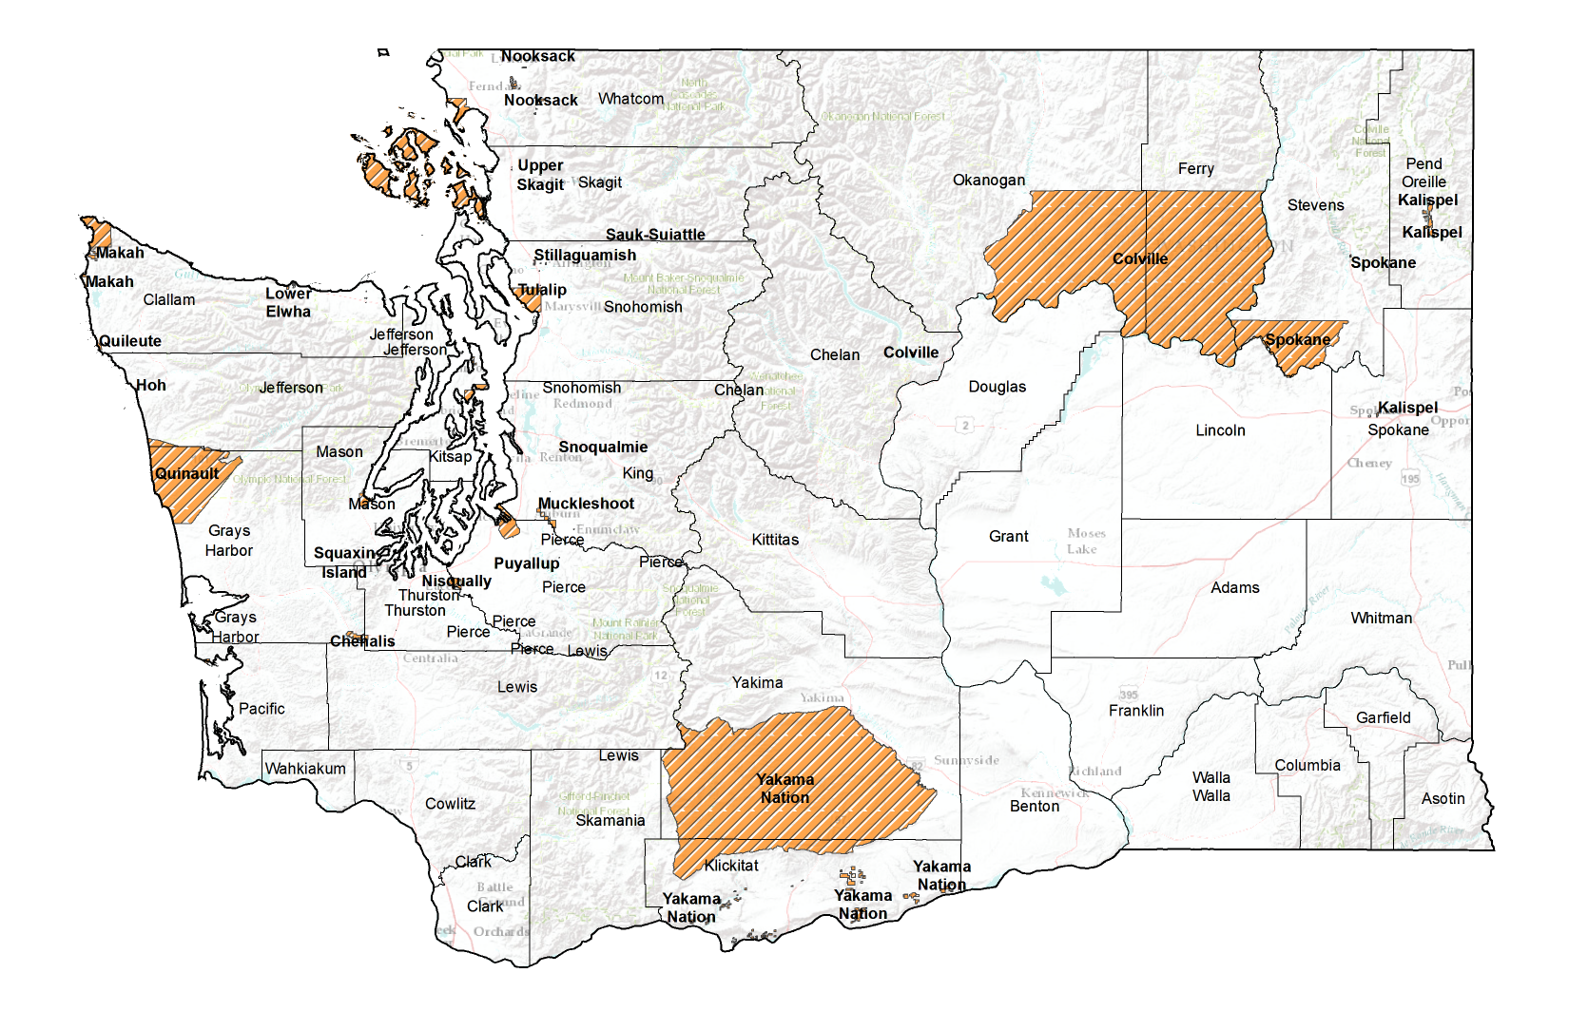
The State of Washington has 29 federally recognized tribes and 17 responded to the NECP Goal 2 Survey. The information is listed below. The Washington tribes are located in the Bureau of Indians Affairs’ (BIA) Northwest Region.
Confederated Tribes of the Chehalis Reservation: Is located in southwest Washington and covers 4,438 acres. The tribe has 833 enrolled members as of 2010 and is home to 661 individuals. The public safety response capabilities are as follows:
- Fire: Local Agency (Rockester Fire, Oakville Fire)
- Wildland Fire: Local Agency (Rockester Fire, Oakville Fire)
- EMS/Rescue: Local Agency (Rockester Fire, Oakville Fire)
- Law Enforcement: Tribal Department (Chehalis Tribal Police)
- Emergency Management: Tribal Department (Chehalis Tribal Police)

The tribe’s emergency dispatch services are handled as follows:
- Law Enforcement: Outside agency operated
- 9-1-1 Communications Center: Tribal and outside agencies operated for non-emergencies, outside agency for emergencies
- Fire Response: Outside agency operated
- Ambulance/EMS Response: Outside agency operated

Confederated Tribes of the Colville Reservation: Land covers 1.4 million acres in North Central Washington, primarily in Okanogan and Ferry Counties. There are 9,365 enrolled members. The NECP Goal 2 Survey response provided no information regarding public safety response or emergency communications and dispatch capabilities.
Cowlitz Indian Tribe: Located in southwest Washington with 2000 members, the tribe incorporates four historical divisions which contribute to the rich cultural heritage of the people: The Upper Cowlitz, The Lower Cowlitz, the Lewis River Cowlitz and the Mountain Cowlitz. The public safety response capabilities are as follows:
- Fire: Local Agency (Longview Fire and Rescue)
- Wildland Fire: Local Agency (Cowlitz County Fire)
- EMS/Rescue: Local Agency (Longview Fire and Rescue)
- Law Enforcement: Local Agency (Longview Police)
- Emergency Management: Local Agency (Cowlitz County)
- Additional Comments: No jurisdictional authority within the Tribe.

The tribe’s emergency dispatch services are handled as follows:
- Law Enforcement: Outside agency operated
- Fire Response: Outside agency operated
- Ambulance/EMS Response: Outside agency operated

Hoh Indian Tribe of the Hoh Indian Reservation: Is located on the Pacific coast on the Olympic Peninsula covering approximately 443 acres with 212 enrolled members. Tribal agencies receive non-emergency calls for service, but emergency (i.e., 9-1-1) calls are received by an outside agency. The public safety response capabilities are as follows:
- Fire: None
- Wildland Fire: State Agency (State DNR)
- EMS/Rescue: Local Agency (Forks Ambulance)
- Law Enforcement: Local Agency (Jefferson County Sheriff)
- Emergency Management: Local Agency (Jefferson County Emergency Management)

Kalispel Indian Community of the Kalispel Reservation: Is located north of Spokane in Pend Oreille County along. The tribe has over 400 members with 1/3 living on the reservation. The public safety response capabilities are as follows:
- Fire: Tribal Department (Kalispel Tribal Fire Department)
- Wildland Fire: Tribal Department (Kalispel Tribal Fire Department)
- EMS/Rescue: Tribal Department (Kalispel Tribal Fire Department)
- Law Enforcement: Tribal Department (Kalispel Tribal Police Department)
- Emergency Management: Tribal Department (Kalispel Tribal EMS)

The tribe’s emergency dispatch services are handled as follows:
- Law Enforcement: Outside agency operated
- 9-1-1 Communications Center: Outside agency operated
- Fire Response: Outside agency operated
- Ambulance/EMS Response: Outside agency operated

Lower Elwha Tribal Community of the Lower Elwha Reservation: Is located in the Lower Elwha River Valley and adjacent bluffs on the north coast of the Olympic Peninsula. There are 1,149 native americans living on or near the Reservation. The public safety response capabilities are as follows:
- Fire: Local Agency (Fire District #2)
- Wildland Fire: Local Agency (Fire District #2)
- EMS/Rescue: Local Agency (Fire District #2)
- Law Enforcement: Tribal Department (Lower Elwha Police Department)
- Emergency Management: Tribal Department (EMS)

The tribe’s emergency dispatch services are handled as follows:
- Law Enforcement: Outside agency operated
- 9-1-1 Communications Center: Outside agency operated
- Fire Response: Tribal agency operated
- Ambulance/EMS Response: Outside agency operated

Muckleshoot Indian Tribe of the Muckleshoot Reservation: Is southeast of the City of Auburn located in King County and Pierce County. There are about 3,300 people living on or near the reservation. The
NECP Goal 2 Survey response provided no information regarding public safety response or emergency communications and dispatch capabilities.

Nisqually Indian Tribe of the Nisqually Reservation: Is located in Thurston County consisting of 1,280 acres. There are 650 enrolled members and most live on or near the reservation. The NECP Goal 2 Survey response provided no information regarding public safety response or emergency communications and dispatch capabilities.
Nooksack Indian Tribe of Washington: Is located in Deming which is 12 miles south of the Canadian Border with approximately 2,000 members. The NECP Goal 2 Survey response provided no information regarding public safety response or emergency communications and dispatch capabilities.
Puyallup Tribe of the Puyallup Reservation: Is located in Tacoma. There are 46,816 individuals who live on the Puyallup Reservation, of whom 2,100 are Native American. The public safety response capabilities are as follows:
- Fire: Local Agency (Tacoma Fire Department)
- Wildland Fire: Other Federal Agency (Department of Natural Resources)
- EMS/Rescue: Local Agency (Tacoma Fire Department)
- Law Enforcement: Tribal Department (Puyallup Tribal Police)
- Emergency Management: Tribal Department (Puyallup Tribal Public Safety)

The tribe’s emergency dispatch services are handled as follows:
- Law Enforcement: Tribal agency operated
- Fire Response: Tribal agency operated
- Ambulance/EMS Response: Outside agency operated

Quileute Tribe of the Quileute Reservation: Is located in La Push on the Pacific Ocean with approximately 2000 members. The NECP Goal 2 Survey response provided no information regarding public safety response or emergency communications and dispatch capabilities.
Sauk-Suiattle Indian Tribe of Washington: Is located in Darrington with approximately 200 members. The NECP Goal 2 Survey response provided no information regarding public safety response or emergency communications and dispatch capabilities.
Shoalwater Bay Tribe of the Shoalwater Bay Indian Reservation: Is located on the southwest coast in Pacific County. There are 237 tribal members who live on or near the reservation.The NECP Goal 2 Survey response provided no information regarding public safety response or emergency communications and dispatch capabilities.
Snoqualmie Tribe: Is located in Carnation with approximately 650 enrolled members. The NECP Goal 2 Survey response provided no information regarding public safety response or emergency communications and dispatch capabilities.

Spokane Tribe of the Spokane Reservation: Consists of 159,000 acres in Wellpinit. As of 2006, tribal membership reached 2441. The Goal 2 Survey response provided no information regarding public safety response or emergency communications and dispatch capabilities.
Suquamish Indian Tribe of the Port Madison Reservation: Is located in northern Kitsap County covering 12 square miles on Port Madison’s western and northern shores. The Tribe has 950 enrolled members of which half live on the reservation. The NECP Goal 2 Survey response provided no information regarding public safety response or emergency communications and dispatch capabilities.
Swinomish Indians of the Swinomish Reservation: Is located on the southeastern end of Fidalgo Island. It covers 15 square miles in size and includes 7,450 acres of upland and approximately 2,990 acres of tidelands. There are approximately 1,000 people on or near the Reservation. The public safety response capabilities are as follows:
- Fire: Local Agency (Skagit County Fire Protection District #13)
- Wildland Fire: Local Agency (Skagit County Fire Protection District #13)
- EMS/Rescue: Local Agency (Anacortes Fire Department)
- Law Enforcement: Tribal Department (Swinomish Police Police)
- Emergency Management: Tribal Department (Swinomish DEM/Swinomish Police Department)

The tribe’s emergency dispatch services are handled as follows:
- 9-1-1 Communications Center: Outside agency operated
- Fire Response: Tribal agency operated

The following Washington Tribes did not respond to the NECP Goal 2 Survey:
- Confederated Tribes of the Chehalis Reservation
- Confederated Tribes of the Colville Reservation
- Confederated Tribes and Bands of the Yakama Nation
- Jamestown S’Klallam Tribe of Washington
- Lummi Tribe of the Lummi Reservation
- Makah Indian Tribe of the Makah Indian Reservation
- Port Gamble Indian Community of the Port Gamble Reservation
- Quinault Tribe of the Quinault Reservation
- Samish Indian Tribe
- Skokomish Indian Tribe of the Skokomish Reservation
- Squaxin Island Tribe of the Squaxin Island Reservation
- Stillaguamish Tribe of Washington
- Tulalip Tribes of the Tulalip Reservation
- Upper Skagit Indian Tribe of Washington

Grant Information

The state of Washington manages its homeland security grants via the Emergency Management Division.
Information can be found at: http://www.emd.wa.gov/grants/grants_index.shtml.

Grant Title | Granting Agency | Grant Year | Amount
Homeland Security Grant Program | FEMA | FY13 | $5,646,176
UASI – Seattle Area | FEMA | FY13 | $5,500,000
State and Local Grant Implementation Program (SLIGP) | NTIA | FY13 | $2,642,591

Interoperable Emergency Communications Grant Program

(2008 – 2010)

Interoperable Emergency Communications Grant Program

(2008 – 2010) (Continued)

Interoperable Emergency Communications Grant Program

(2008 – 2010) (Continued)

Interoperable Emergency Communications Grant Program

(2008 – 2010) (Continued)

Interoperable Emergency Communications Grant Program

(2008 – 2010) (Continued)

Washington NECP Goal 2 Results

In July 2008, the U.S. Department of Homeland Security (DHS) Office of Emergency Communications (OEC) published the National Emergency Communications Plan (NECP), the first national strategic plan for improving emergency communications across all levels of government. The NECP established a set of goals to measure progress toward this vision.
For Goal 2 of the NECP, OEC worked with States and Territories to assess emergency communications at a more granular level, including counties and county equivalents such as parishes, municipalities, and townships. The result is the most comprehensive and detailed account of emergency communications capabilities involving rural, urban, and border jurisdictions across the Nation.
Goal 2 Performance Results
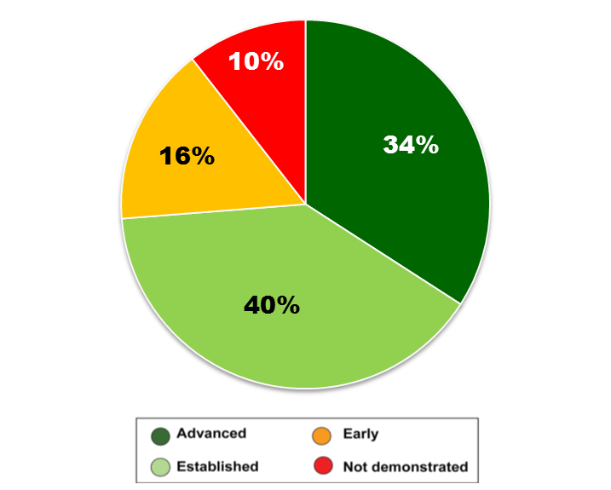
To measure Goal 2, counties or county-level equivalents evaluated their ability to demonstrate response-level emergency communications during local emergencies, including unplanned incidents (e.g., tornadoes, vehicle accidents, missing persons, and earthquakes) and planned events (e.g., National Security Special Events [NSSE], large public gatherings, and National and State exercises). The jurisdictions then sent the results to their respective Statewide Interoperability Coordinators (SWIC), who were responsible for validating the data and formally submitting to OEC.
The criteria for achieving the goal was based on: (1) policies and procedures; (2) responder roles and responsibilities; and (3) technical quality and continuity. The counties were asked to assess their interoperable communications and received scores based on the following four levels of demonstration:
- Advanced
- Established Demonstration
Percentage Breakdown of Goal 2 Performance Results by Demonstration Level
- Early Demonstration
- Not Demonstrated
In total, 90 percent of responding jurisdictions were able to achieve response-level communications.

Washington NECP Goal 2 Results

*The maps below represent Goal 2 Results submitted July 2012 from exercises, planned or unplanned events in Washington including, but not limited to: WSU vs. UW Football Game, Airport Exercise, Flooding, Fires, and Boat Races.
.

Washington counties who have submitted NECP Goal 2 Capability and/or Performance Reports

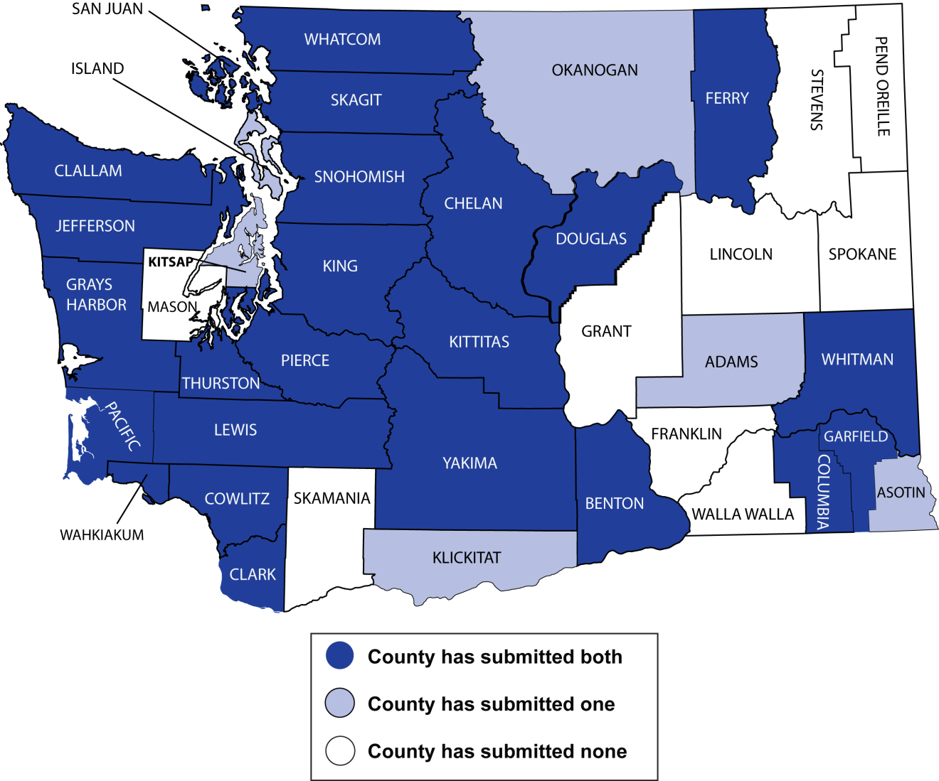

Washington NECP Goal 2 Results

Washington Capability Overview
Use of Interoperable Communications:The SAFECOM Baseline Survey and the NECP Goal 2 assessments both addressed the frequency and ease in which jurisdictions use of interoperable communications solutions. Their ability to use interoperable solutions during daily, more localized response operations is also closely related to ability to use during large scale incidents. The Goal 2 results show that the percentage of jurisdictions nationwide that regularly achieve interoperability has increased from 66 percent in 2006 to 85 percent in 2011.
Merged Capability Scores:Represents weighed average of key communications interoperability capabilities within the county (Governance, SOPs, Training, Usage)

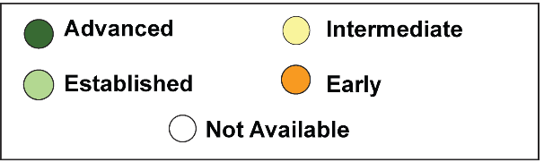
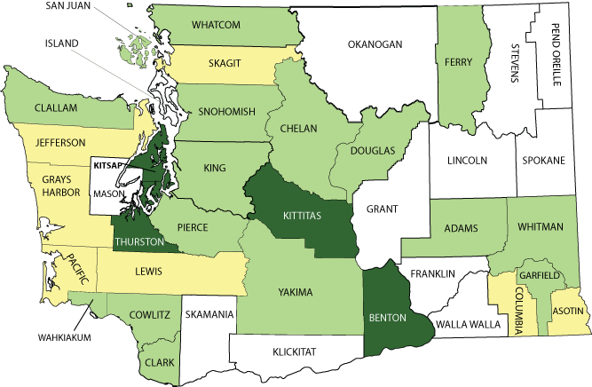

Washington NECP Goal 2 Results

Capabilities Details: Governance
Governance:The percentage of jurisdictions that participate in multi-jurisdictional interoperability governance groups across the nation has doubled in the last five years.
Governance | Early  Implementation | County-wide decision-making groups are informal and do not yet have a strategic plan to guide collective communications interoperability goals and funding.
Governance | Intermediate Implementation | Some formalagreements exist and informal agreements are in practice among members of the decision making group for the County. Strategic and budget planning processes are beginning to be put in place.
Governance | Established Implementation | Formal agreements outline the roles and responsibilities of a county-wide decision making group, which has an agreed upon strategic plan that addresses sustainable funding for collective, regional interoperable communications needs.
Governance | Advanced Implementation | County-wide decision making bodies proactively look to expand membership to ensure representation from broad public support disciplines and other levels of government, while updating their agreements and strategic plan on a regular basis.

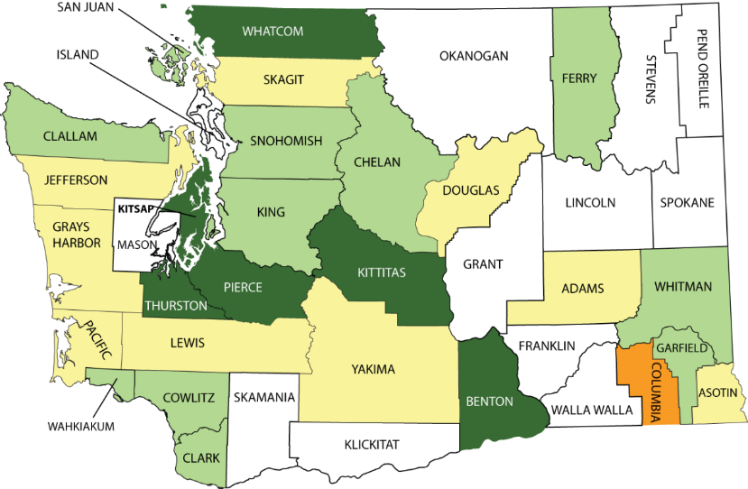

Washington NECP Goal 2 Results

Capabilities Details: SOPs
Standard Operating Procedures:Nationwide, the percentage of jurisdictions with formal interoperability SOPs increased from 60 percent in 2006 to 85 percent in 2011. SOPs are designed to address the activation and use of interoperability equipment, as well as command and control procedures through NIMS.

Standard Operating Procedures | Early  Implementation | County-wide interoperable communications SOPs are not developed or have not been formalized and disseminated.
Standard Operating Procedures | Intermediate Implementation | Some interoperable communications SOPs exist within the county and steps have been taken to institute these interoperability procedures among some agencies.
Standard Operating Procedures | Established Implementation | Interoperable communications SOPs are formalized and in use by all agencies within the county Despite minor issues, SOPs are successfully used during responses and/or exercises.
Standard Operating Procedures | Advanced Implementation | Interoperable communications SOPs within the county are formalized and regularly reviewed. Additionally, NIMS procedures are well established among all agencies and disciplines. All needed procedures are effectively utilized during responses and/or exercises.
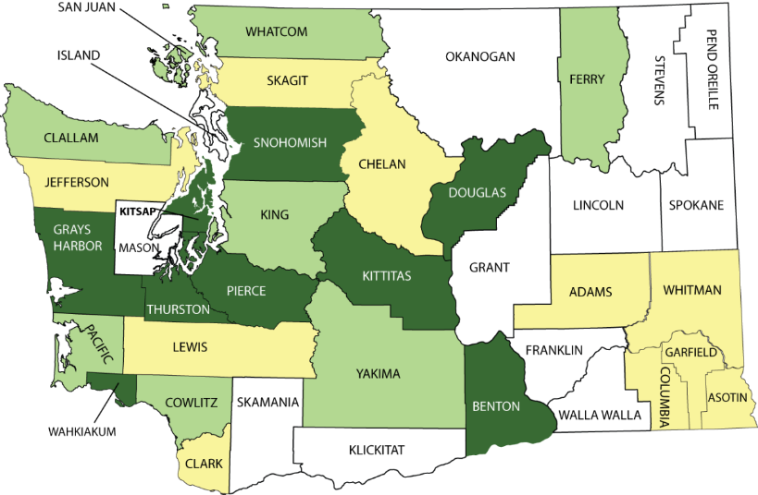

Washington NECP Goal 2 Results

Capabilities Details: Training & Exercises

Training & Exercises | Early  Implementation | County-wide public safety agencies participate in communications interoperability workshops, but no formal training or exercises are focused on emergency communications.
Training & Exercises | Intermediate Implementation | Some public safety agencies within the county hold communications interoperability training on equipment and conduct exercises, although not on a regular cycle.
Training & Exercises | Established Implementation | Public safety agencies within the county participate in equipment and SOP training for communications interoperability and hold exercises on a regular schedule.
Training & Exercises | Advanced Implementation | County public safety agencies regularly conduct training and exercises with communications interoperability curriculum addressing equipment and SOPs that is modified as needed to address the changing operational environment.
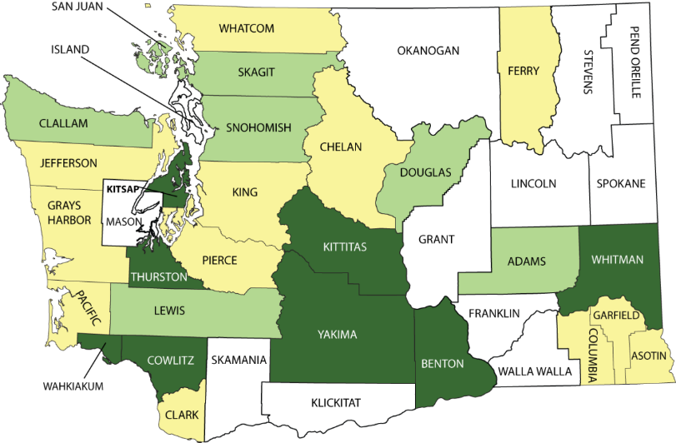

Washington NECP Goal 2 Results

Capabilities Details: Usage

Usage | Early  Implementation | First responders across the county seldom use solutions unless advanced planning is possible (e.g., special events).
Usage | Intermediate Implementation | First responders across the county use interoperability solutions regularly for emergency events, and in limited fashion for day-to-day communications.
Usage | Established Implementation | First responders across the county use interoperability solutions regularly and easily for all day-to-day, task force, and mutual aid events.
Usage | Advanced Implementation | Regular use of solutions for all day-to-day and out-of-the-ordinary events across the county on demand, in real time, when needed, as authorized.
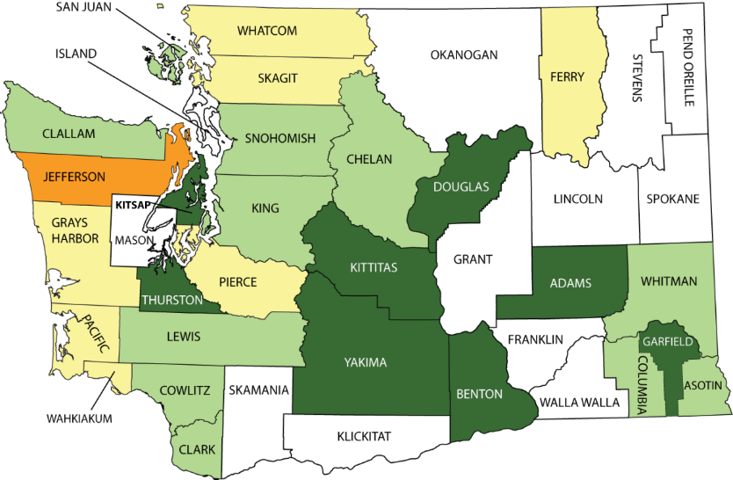

Washington NECP Goal 2 Results

Washington Overall Performance Results

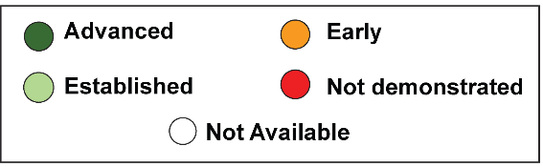
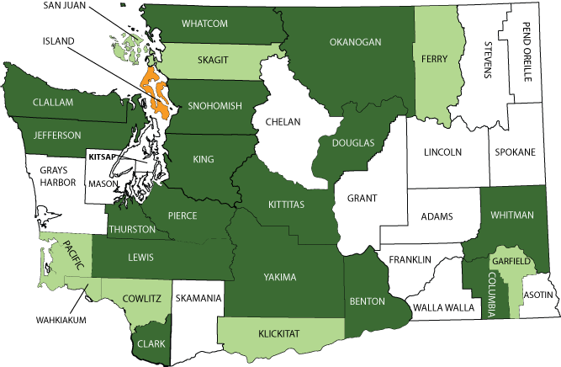

Washington NECP Goal 2 Results

Performance Details: Policies & Procedures
Were established interagency communications policies and procedures followed throughout the incident, planned event, or exercise?
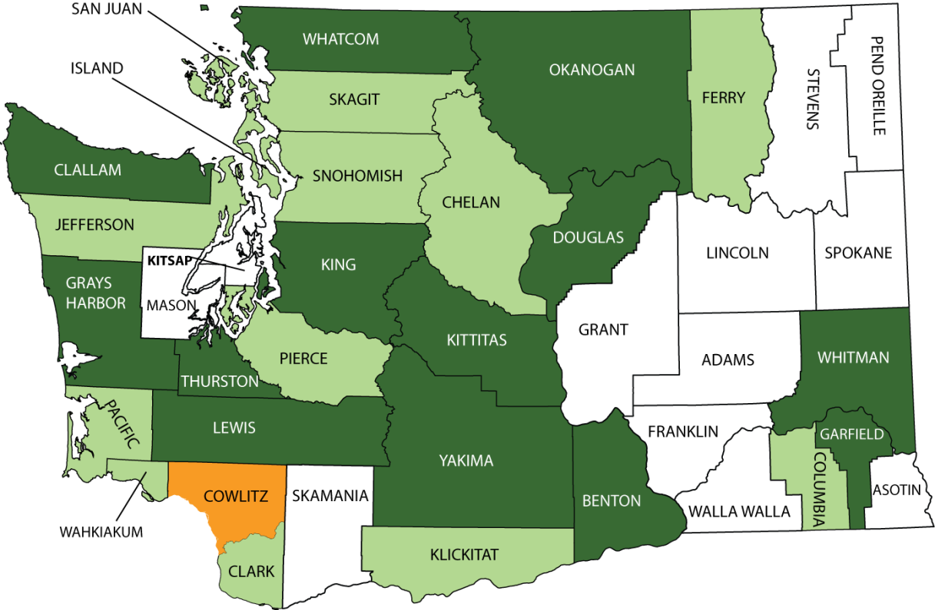

Washington NECP Goal 2 Results

Performance Details: COML
Were COML roles and responsibilities carried out, either by the Incident Commander (or Unified Command), the COML, or another designee?
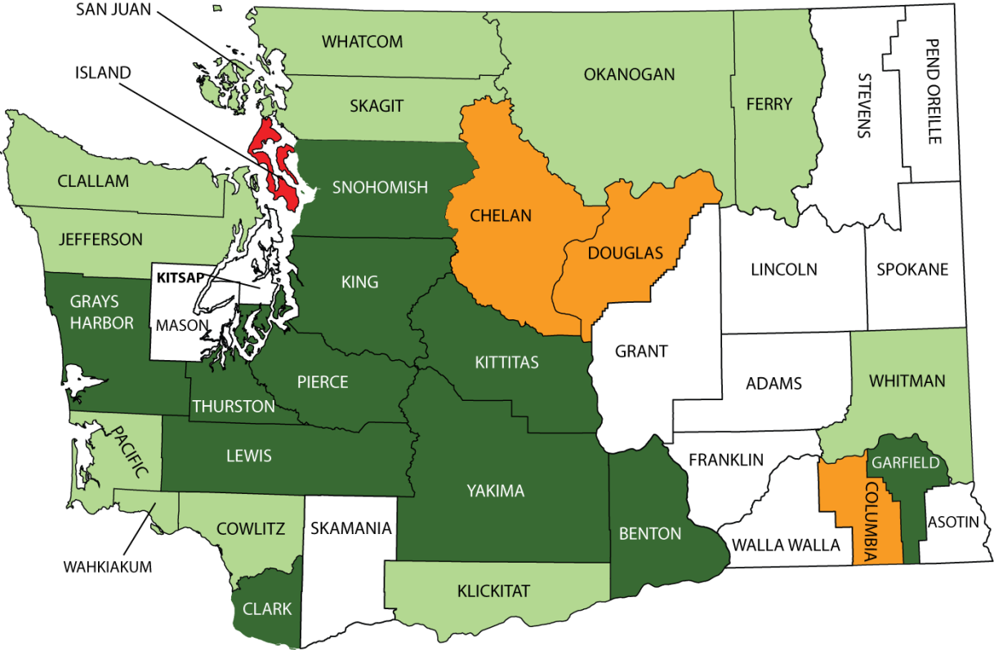

Washington NECP Goal 2 Results

Technology Details – Primary Interoperability Method
Level | Question
Early | Interoperability within the area is primarily achieved through the use of gateways (mobile/fixed gateway, console patch), shared radios, or use of a radio cache
Intermediate | Interoperability within the area is primarily achieved through the use of shared channels or talk groups.
Established | Interoperability within the area is primarily achieved through the use of a proprietary shared system.
Advanced | Interoperability within the area is primarily achieved through the use of standards-based shared system (e.g., Project 25).

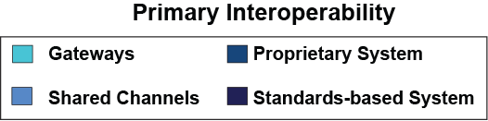
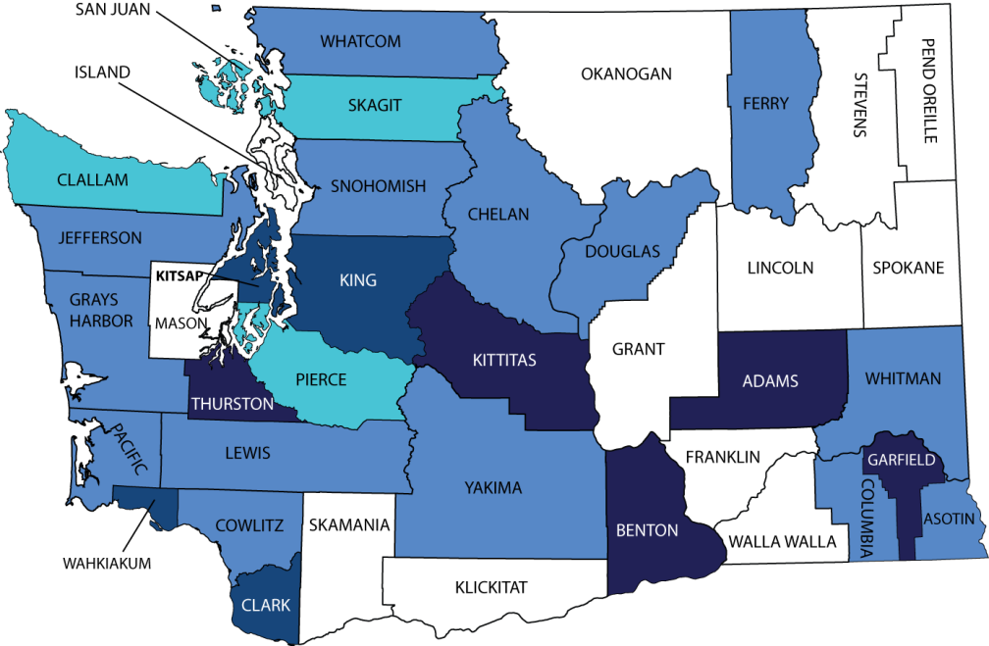

Washington NECP Goal 2 Results

Percentage of Responses Using: Cell/Sat Phones
Cellular Voice: Over 69 percent of all counties nationwide indicated that cellular phones were used during most or all of their public safety responses. It should be noted that this does not indicate that the counties are using cellular technology as their primary communications method or in place of LMR.
Counties were asked to estimate the percentage of public safety responses that utilize the following technologies during response operations.

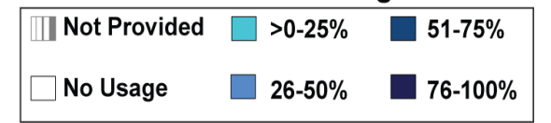
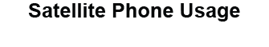
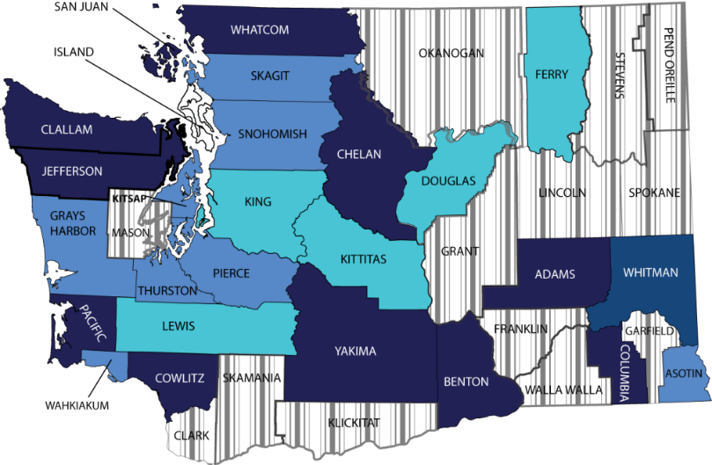
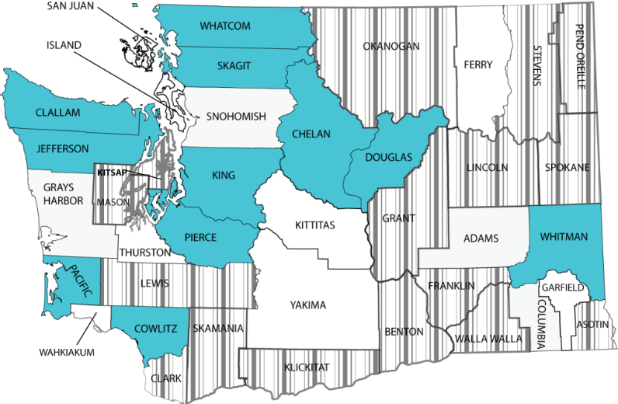

Washington NECP Goal 2 Results

Percentage of Responses Using: Mobile Data
Mobile Data: In addition to LMR, the Goal 2 evaluations noted the use of mobile data (both low-speed private networks and commercial broadband technology) to support public safety responses. A total of 70 percent of counties nationwide reported the use of commercial mobile data, with 23 percent of responding counties using mobile data on most public safety responses.
Counties were asked to estimate the percentage of public safety responses that utilize the following technologies during response operations.

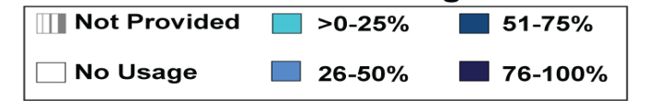


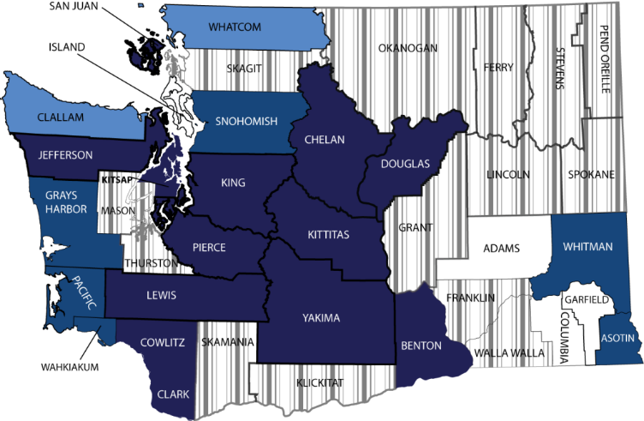
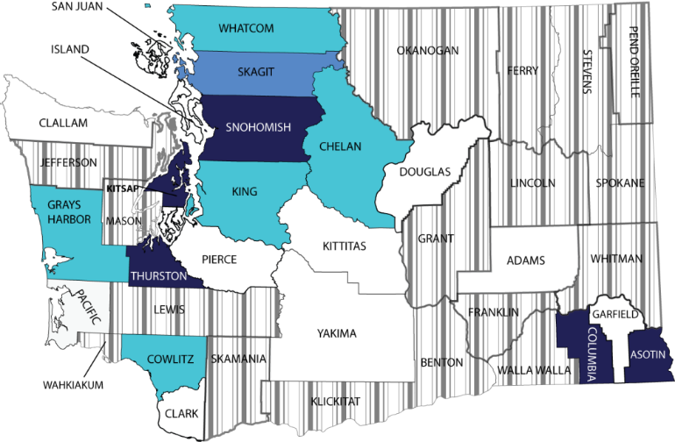
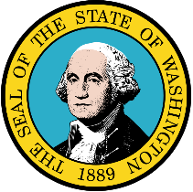
Washington Statewide Communications Interoperability Plan

Most Recent SCIP Needed

WashingtonRadio Systems and Infrastructure
Washington Radio Systems and Infrastructure

Washington Tower Locations

All Washington Towers

The map below shows all of the private public safety land mobile radio towers in the State of Washington.
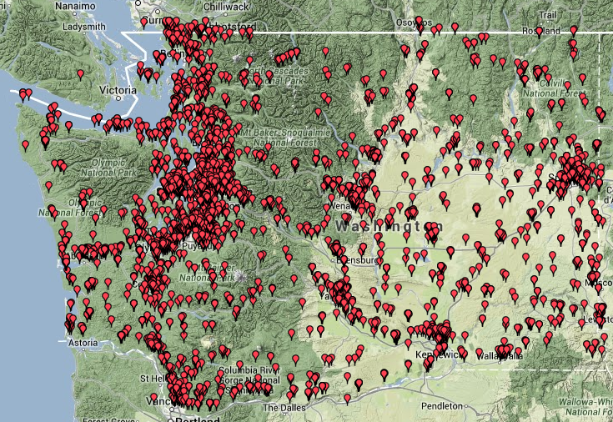

*Screenshot from July 2014 from the Frequency Mapping Tool at: http://www.publicsafetytools.info/

Washington Radio Systems

The radio systems across the state are demarcated by their frequency in the map below.

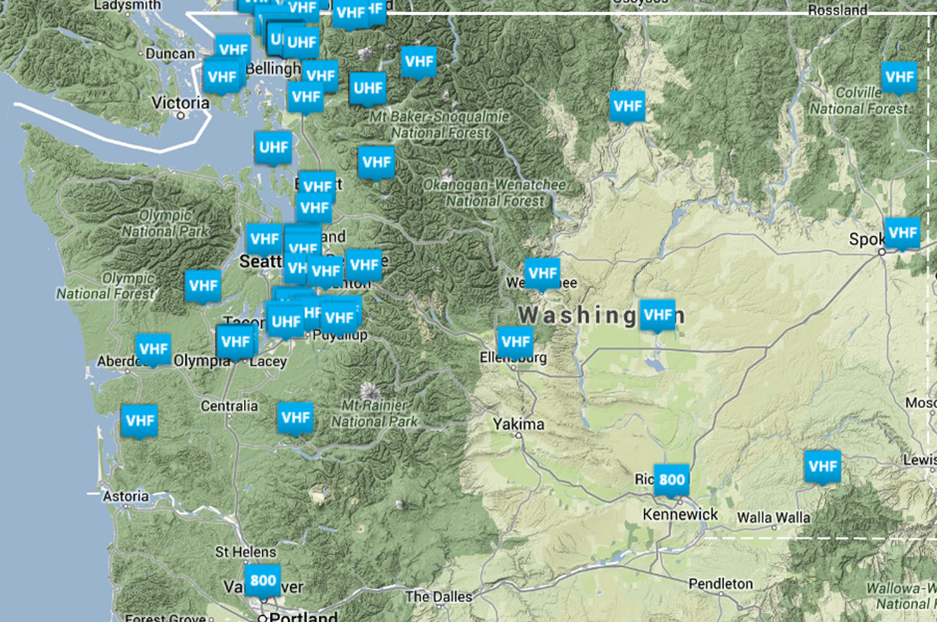

*Screenshot from June 2014 from CASM NextGen at: https://casmnextgen.com

Legend:
- “800” – 800 MHz Radio System
- “VHF” – VHF Radio System
- “UHF” – UHF Radio System

Washington Tactical and Incident Resources

Communications Equipment

Washington Radio Caches

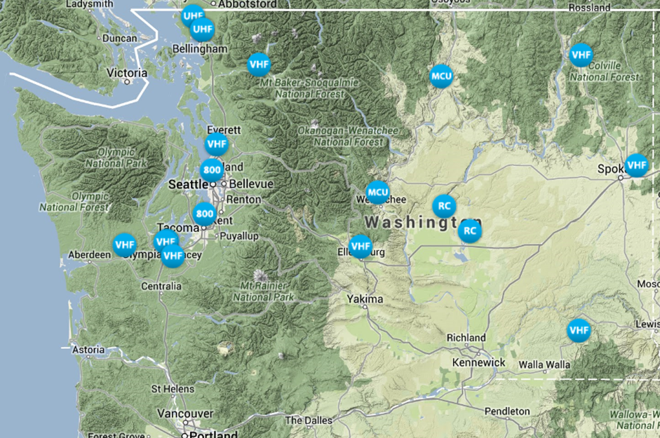
The radio caches across the state are demarcated by their frequency in the map below.

*Screenshot and information from June 2014 from CASM NextGen at: https://casmnextgen.com

Communications Unit Personnel Resources

The below tables reflect personnel in Washington who have completed a COML or COMT training courses. Please note that this does not indicate that the personnel are fully certified COMLs or COMTs according to Washington regulations.

Washington Interoperable Emergency Communications Technical Assistance

Interoperable Emergency Communications Technical Assistance Quick Reference

Since 2007 the Department of Homeland Security’s Office of Emergency Communications Interoperable Communications Technical Assistance Program (OEC/ICTAP) has delivered over 1,000 technical assistance courses and workshops in every State and Territory. The goal of the program is to ensure, accelerate, and attain operable and interoperable emergency communications nationwide. The tables below synopsize the previous interoperable communications technical assistance workshops/trainings previously carried out and scheduled to be carried out in Washington.
Previous Technical Assistance
Date | Type | Location | Attendees
December 5, 2013 | First Net Pre-Consultation Planning Workshop | Tacoma | 45
September 20, 2013 | Introduction to Interoperable Radio Operations | Ferndale | 14
July 22, 2013 | NIMS ICS All-Hazards Communications Unit Technician Course | Seattle | 14
May 21 – 23, 2013 | Public Safety Communications Centers' Continuity of Operations Plan | Burien | 32
December 10, 2012 | NIMS ICS All-Hazards Communications Unit Technician Course | Seattle | 15
November 17, 2012 | Auxiliary Communications Workshop | Seattle | 26
February 10, 2011 | Assessment of Standard Operating Procedures/Communications Plans | Yakima | 9
January 11, 2011 | Assessment of Standard Operating Procedures/Communications Plans | Ellensburg | 9
December 8, 2010 | Assessment of Standard Operating Procedures/Communications Plans | Bellevue | 9
October 13, 2010 | Audio Gateway Information and Training | Bremerton | 30
October 12, 2010 | Audio Gateway Information and Training | Ellensburg | 30
September 21, 2010 | Assessment of Standard Operating Procedures/Communications Plans | Wenatchee | 9
September 9, 2010 | Tactical Interoperable Communications Field Operations Guide Development | Seattle | 12
August 2010 | LMR System Analysis | Stevens County | 10
July 22, 2010 | Assessment of Standard Operating Procedures/Communications Plans | Spokane | 9
June 1, 2010 | Shared Resource Analysis and Coordination | Not Provided | 34
April 21, 2010 | Assessment of Standard Operating Procedures/Communications Plans – Working Group Meeting | Yakima | 9
February 2, 2010 | Audio Gateway Information and Training | Spokane | 30
Previous Technical Assistance (Continued)
Date | Type | Location | Attendees
December 29, 2009 | CASM Support | Not Provided
December 2, 2009 | Audio Gateway Information and Training | Seattle | 30
September 21, 2009 | Microwave Design Analysis | Tumwater | 15
July 21, 2009 | LMR System Analysis | Seattle | 10
July 13, 2009 | Development of Governance Structure Models | Spokane | 15
October 31, 2008 | LMR System Analysis | Not Provided | 10
October 7, 2008 | Development of Governance Documentation | Not Provided | 10
August 28, 2008 | CASM Set-Up | Not Provided | 25

Upcoming Technical Assistance
Date | Type | Location | Description
October 4, 2014 | Auxiliary Communications Workshop | Everett | Training for auxiliary emergency communicators
September 22, 2014 | Communications Unit Leader (COML) Training | Everett | FEMA certified COML training
Ongoing | Strategic Resource Allocation Guide Development | Various | Multi-state resource guide for cross border resource requests

Washington 9-1-1 and Next Generation 9-1-1

Washington 9-1-1 Program
Governance:
Structure: The Washington State Enhanced 9-1-1 (E9-1-1) Program began as the result of a 1991 voter referendum and is administered under the Emergency Management Division of the Washington Military Department. The E9-1-1 Unit works with counties and communications’ companies to ensure the E911 operations and availability. The Program is headed by the State E9-1-1 Coordinator and a State E9-1-1 Advisory Committee provides advice and assistance.

State E-9-1-1 Coordinator:
Sigfred “Ziggy” Dahl
253-512-7468
Sigfred.dahl@mil.wa.gov

State E9-1-1 Advisory Committee:
The E9-1-1 Advisory Committee is made up of individuals representing different public safety and communications organizations including, but not limited to: State firefighters associations, State police associations, State and local government associations, and telephone companies.
Leadership:
Position | Name | E-Mail
Chair | Peggy Fouts | pfouts@gh911.org
Vice Chair | Lorlee Mizell | l.mizell@spokanecounty.org

Washington Public Safety Answering Points (PSAPS) Locations

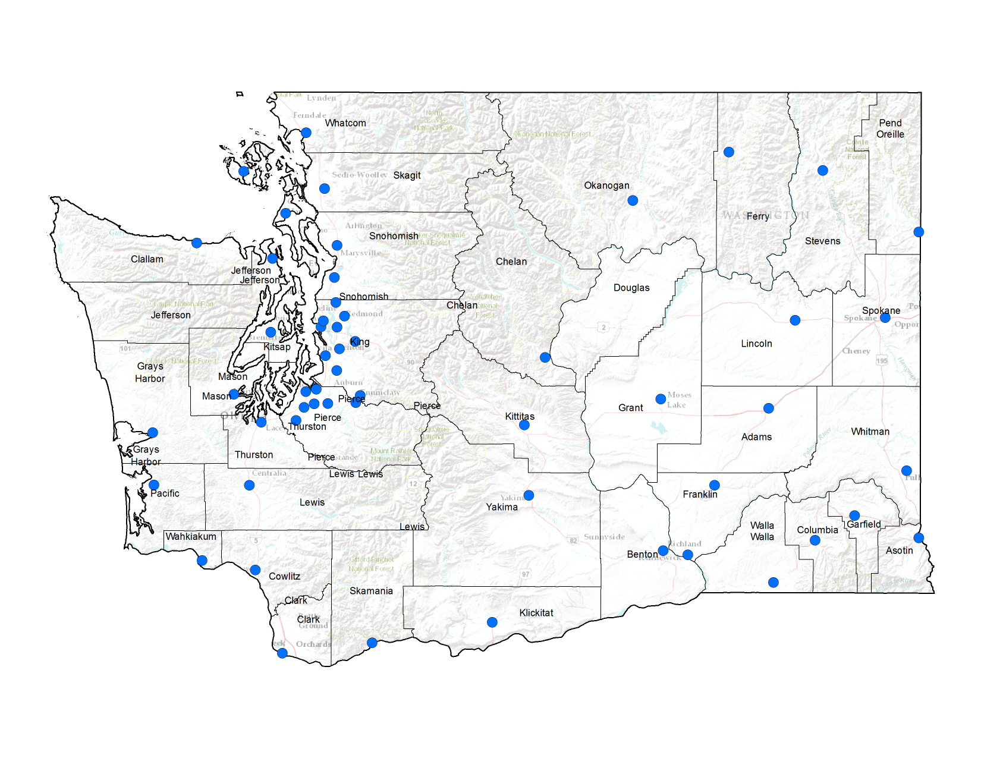
Primary PSAP and Points of Contact
Name | County | City | Point of Contact
Adams County Sheriff’s Office | Adams | Ritzville | Angela Fode, 911 Coordinator  509-659-1122
Prosser Police Department | Benton | Prosser | N/A
Southeast Communications Center | Benton | Richland | Jim Barber, 911 Coordinator  509-628-8595
RiverCom | Chelan | Wenatchee | Jim Fosse, Director  509-662-4650
Washington State Patrol Wenatchee | Chelan | Wenatchee | N/A
PENCOM-Clallam County | Clallam | Port Angeles | Steve Romberg, Comm. Manager  360-417-4970
Clark Regional Emergency Services Agency | Clark | Vancouver | Anna Pendergraff, Director  360-696-4461
Columbia County Sheriff’s Office | Columbia | Dayton | James LaTour, Sheriff  509-382-2518
Cowlitz County 9-1-1 Center | Cowlitz | Kelso | Laurie Masse, 911 Coordinator  360-577-3078
Ferry County E9-1-1 | Ferry | Republic | Raymond Maycumber, 911 Coordinator  509-775-3136
Franklin County Sheriff’s Office | Franklin | Pasco | Ed Bush, 911 Coordinator  509-546-5891
Garfield County Sheriff’s Office | Garfield | Pomeroy | Kathleen Slaybaugh, E911 Coordinator  509-843-3494
Multi Agency Communications Center | Grant | Moses Lake | Jackie Jones Allen, 911 Coordinator  509-762-1901
Grays Harbor Communications | Grays Harbor | Aberdeen | Peggy Fouts, 911 Director  360-533-7885
Quinault Nation Police Department | Grays Harbor | Taholah | N/A
Island County Emergency Services Communications Center | Island | Oak Harbor | Tom Shaughnessy, 911 Coordinator  360-679-9567
US Naval Air Station Island Security Department | Island | Oak Harbor | N/A
Naval Air Station Whidbey Island | Island | Oak Harbor | N/A
JeffCom 9-1-1 Communications | Jefferson | Port Hadlock | Karl Hatton, Director  360-385-3831
Bothell Police Department | King | Bothell | Micki Singer, Support Services Mng.  425-486-1254
Enumclaw Police Department | King | Enumclaw | Mimi Jensen, Comm. Supervisor  360-825-3505
Issaquah Police Department | King | Issaquah | Dee Ann Edwards, Comm. Supervisor  425-837-3200
King County Sheriff's Office | King | Seattle | Jean Best, Operations Manager  206-296-3311

The information in the below is gathered from the Federal Communications Commission Primary PSAP listing and the National Public Safety Information Bureau 2013.

Primary PSAP and Points of Contact (Continued)
Name | County | City | Point of Contact
NORCOM (North East King County Regional Public Safety Communication Agency) | King | Bellevue | Sheryl Mullen, 911 Supervisor  425-577-5600
Port Of Seattle Police Department | King | Seattle | Kathy McCaughn, Manager  206-787-5400
Redmond Police Department | King | Redmond | Robert Clemmons, Comm. Supervisor  425-556-2500
Seattle Police Department | King | Seattle | Sean O’Donnell, Comm. Director  206-684-8640
University Of Washington Police Department | King | Seattle | S. Carr, Tech Service Manager  206-685-8973
Valley Communications Center-king County | King | Kent | Laura Ueland, Director  253-372-1300
Washington State Patrol Bellevue | King | Bellevue | N/A
Kitsap County Central Communications | Kitsap | Bremerton | Richard Kirton, 911 Director  360-308-5400
Port Gamble Tribal Police Department | Kitsap | Kingston | N/A
Regional Dispatch Center | Kitsap | Silverdale | N/A
Suquamish Tribal Police Department | Kitsap | Suquamish | N/A
Naval Base Kitsap-Bangor | Kitsap | Silverdale | N/A
Kittitas County 911 | Kittitas | Ellensburg | Darlene Mainwaring, 911 Coordinator  509-925-8530
Klickitat County Sheriff’s Office | Klickitat | Goldendale | Robert Allen, 911 Coordinator  509-773-4545
Lewis County 9-1-1 Communications Division | Lewis | Chehalis | Craig Larsen, 911 Coordinator  360-740-1464
Lincoln County Sheriff’s Office | Lincoln | Davenport | Jo Borden, 911 Coordinator  509-725-3501
Shelton Police Department MACECOM | Mason | Shelton | Michael Evans, Director  360-432-5140
Okanogan County Sheriff’s Office | Okanogan | Okanogan | Jennifer Johnson, 911 Coordinator  509-422-7232
Pacific County Sheriff’s Office | Pacific | South Bend | Stephanie Fritts, 911 Coordinator  360-875-9397
Raymond Fire Department | Pacific | Raymond | N/A
Pend Oreille 9-1-1 | Pend Oreille | Newport | JoAnn Boggs, 911 Coordinator  509-447-3731
Buckley Police Department | Pierce | Buckley | Kathy Loye, Comm. Supervisor  360-829-3157
Fife Police Department | Pierce | Fife | Mark Mears, Assistant Chief  253-922-6633
Joint Base Lewis McChord | Pierce | Tacoma | Jeffrey Rodemane, Comm. Director  253-967-3107
Law Enforcement Support Agency | Pierce | Tacoma | Diana Lock, Assistant Director  253-798-4722

Primary PSAP and Points of Contact (Continued)
Name | County | City | Point of Contact
Mt Rainer National Park Communications Center | Pierce |  | N/A
Puyallup Communications | Pierce | Puyallup | Tim Hannah, Comm. Center Manager  253-841-5431
Sumner Communications | Pierce | Sumner | N/A
Tacoma Fire Department | Pierce | Tacoma | N/A
Washington State Patrol | Pierce | Tacoma | Laurie Langlois, Comm. Manager  253-538-3240
San Juan County Sheriff’s Office | San Juan | Friday Harbor | Robin DelaZerda, 911 Coordinator  360-378-1345
Skagit County 9-1-1 Emergency Communications Center | Skagit | Mt Vernon | Deb Flewelling, Director  360-428-3200
Swinomish Tribal Police Department | Skagit | La Conner | N/A
Upper Skagit Tribal Police | Skagit | Sedro Woolley | N/A
Skamania County Sheriff’s Office | Skamania | Stevenson | Dave Cox, 911 Coordinator  509-427-9490
Sauk-Suiattle Tribal Police Department | Snohomish | Darrington | N/A
SNOCOM | Snohomish | Mountlake Terrace | Debbie Grady, Executive Director  425-774-2501
Snohomish County-SNOPAC | Snohomish | Everett | Kurt Mills, Executive Director  425-407-3911
Naval Station Everett | Snohomish | Everett | N/A
Washington State Patrol Marysville | Snohomish | Marysville | Andrea Marlow, Comm. Manager  360-654-1204
Spokane County 9-1-1 Emergency Communications | Spokane | Spokane | Amy McCormick, 911 Coordinator  509-532-8911
Stevens County Department Of Emergency Services | Stevens | Colville | Debbie McCanna, 911 Coordinator  509-684-2555
Thurston County-Capcom | Thurston | Olympia | Jim Quackenbush, 911 Coordinator  360-704-2740
Walla Walla Emergency Services Communications Center | Walla Walla | Walla Walla | Steve Ruley, Comm. Manager  509-527-1960
Prospect Fire-EMS Dispatch-Bellingham Fire Department | Whatcom | Bellingham | N/A
WHATCOMM Communications Center | Whatcom | Bellingham | William Slodysko, Deputy Director  360-676-6911
WHITCOM | Whitman | Pullman | Patti Kelly, 911 Director  509-332-2521
Yakima Public Safety Communications | Yakima | Yakima | Wayne Wantland, 911 Director  509-575-6048

Next Generation 9-1-1

Next Generation 9-1-1 Overview:
Next Generation 9-1-1 (NG9-1-1) is an initiative to update and enhance the 9-1-1 service infrastructure throughout the United States. NG9-1-1 aims to keep pace with new communication technology, offering benefits to both 9-1-1 operators and emergency responders, as well as callers.

NG9-1-1 Features:
- Location-centric technology with caller location embedded in call delivery packets
- Increased data bandwidth to allow for text and video in addition to voice
- Better sharing and consolidation of resources among agencies and PSAPs
- A framework to support future technology

Current Status of Washington’s NG9-1-1:
The E9-1-1 Advisory Committee’s NG9-1-1 Subcommittee has made progress in implementing NG9-1-1 standards across the state since its inception in 2007. The Subcommittee has developed a 6 phase plan for bringing NG9-1-1 technology to the state. The following comes directly from the Subcommittee’s NG9-1-1 Plan Report from 2012:
Phase 1. (Funded)
A state contract was awarded to CenturyLink and Intrado for a Next Generation 9-1-1 network and database pilot project in Benton, Ferry, Island, Lewis, Skamania, Spokane, Thurston, and Yakima Counties.
- Status: COMPLETED. January 2012

Phase 2. (Funded)
Implementation of the Next Generation 9-1-1 network and database in theremaining 31 counties and Washington State Patrol (WSP) E9-1-1 Public Safety Answering Points.
- Status: COMPLETED March 2012

Phase 3. (Progress directly limited by annual revenue)
Consolidation of telecommunications equipment and implementation of i3 capability at all PSAPs. This is the final phase of telecommunications upgrades resulting in full digital-to-digital voice and data from start to finish. It is the most time consuming and expensive phase of the modernization.
- Status: IN PROGRESS.

Phase 4.
Terminate end office trunks directly to IP gateways. When completed, legacy selective routers go away; start date: Oct 2012.
- Status: IN PROGRESS.

Phase 5.
Convert remaining essential PSAP equipment (e.g. logging recording, CAD) to i3 standard.
- Status: IN PLANNNING

Phase 6.
Modernize geographic information systems.
- Status: IN PLANNNING

Broadband & FirstNet

Page Intentionally Left Blank

References

References

Public Safety Tools:http://www.publicsafetytools.info/start_index_v2.php

National Telecommunications & Information Administration:http://www.ntia.doc.gov/

Office of Emergency Communications (OEC):http://www.dhs.gov/about-office-emergency-communications

Federal Emergency Management Agency:http://www.fema.gov/

FirstNet:http://www.firstnet.gov/

Points of Contact

OEC Coordinator:Bruce Richter
202-603-3841
Bruce.Richter@hq.dhs.gov

OEC Technical Assistance Branch:OEC@dhs.gov

Individuals with State CASM Access

Name | Agency | Phone | Email

Much of this information comes directly from the Washington Emergency Support Function #2, located at: http://www.emd.wa.gov/plans/documents/Planning_cemp_ESF2.pdf
This information is derived from the FEMA Disaster Declarations site located at: https://www.fema.gov/disasters
http://www.npaihb.org/member_tribes/tribe/chehalis_tribe
http://www.colvilletribes.com/facts.php
http://cwis.org/GML/cowlitz/
http://www.npaihb.org/member_tribes/tribe/hoh_tribe
http://kalispeltribe.com/our-tribe/past-present-future
http://www.npaihb.org/member_tribes/tribe/lower_elwha_tribe
http://www.muckleshoot.nsn.us/media/20315/september%202009%20lw%20res.pdf
http://www.nisqually-nsn.gov/content/our-history
http://www.nooksacktribe.org/about/
http://www.ofm.wa.gov/pop/census2010/sf1/data/tribal/wa_2010_sf1_tribal_28000US56720.pdf
http://www.quileutenation.org/
http://www.sauk-suiattle.com/
http://www.npaihb.org/member_tribes/tribe/shoalwater_bay_tribe
http://www.snoqualmienation.com/content/about-snoqualmie-tribe
http://www.spokanetribe.com/about
http://suquamish.nsn.us/HistoryCulture.aspx
http://www.swinomish-nsn.gov/community.aspx
http://www.npaihb.org/member_tribes/tribe/swinomish_tribe
“Most or all” is defined as being used between 50 percent and 100 percent of response operations

